**Data Structures Lab 6**

**Course:** Data Structures (CL2001) **Semester:** Fall 2023

**Instructor: Shafique Rehman**

**Note:**

* + - * Lab manual cover following below Advance sorting algorithms

**{Radix Sort, Linear Search, Binary Search and Interpolation Search}**

* Maintain discipline during the lab.
* Just raise hand if you have any problem.
* Completing all tasks of each lab is compulsory.
* Get your lab checked at the end of the session.

**Radix Sort (Bucket Sort):**

Radix sort is a non-comparative sorting algorithm. It avoids comparison by creating and distributing elements into buckets according to their radix. For elements with more than one significant digit, this bucketing process is repeated for each digit, while preserving the ordering of the prior step, until all digits have been considered. For this reason, radix sort has also been called bucket sort and digital sort.

* Step 1 – Take input array and find MAX number in the array
* Step 2 – Define 10 queues each representing a bucket for each digit from 0 to 9.
* Step 3 – Consider the least significant digit of each number in the list which is to be sorted.
* Step 4 – Insert each number into their respective queue based on the least significant digit.
* Step 5 – Group all the numbers from queue 0 to queue 9 in the order they have inserted into their respective queues.
* Step 6 – Repeat from step 3 based on the next least significant digit.
* Step 7 – Repeat from step 2 until all the numbers are grouped based on the most significant digit.
* <https://www.youtube.com/watch?v=XiuSW_mEn7g>

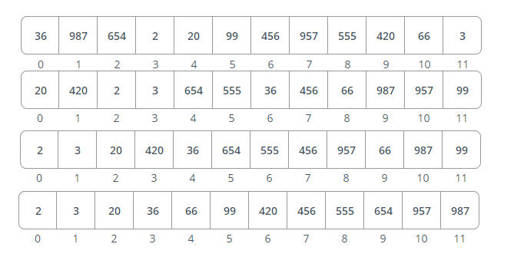

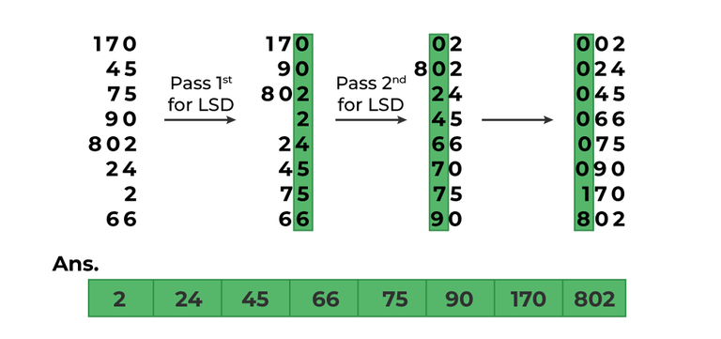

**Task 1:**

Given the array in the above-mentioned figure implement using radix sort.

**Task 2:**

Given an array in the above figure of integers, sort the array in ascending as well as descending order and return it using radix sort

**Task 3**

Consider 10, 1, 5, 6, 12, 2, 5, 3, 13, 17, 14 an array of integers, to do two-way sort using radix in bucket sort. First sort odd numbers in descending order, then sort even numbers in ascending order.

See Example:



**Linear Search**

Linear search algorithm or sequential search is a method for finding an element within a list. It sequentially checks each element of the list until a match is found or the whole list has been searched.

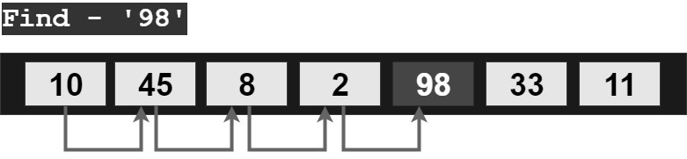

**Binary Search**

Binary search algorithm falls under the category of interval search algorithms. This algorithm is much more efficient compared to linear search algorithm. Binary search only works on sorted data structures. This algorithm repeatedly target the center of the sorted data structure & divide the search space into half till the match is found.

**Algorithm:**

* ***Take input array, left, right & x***
* ***START LOOP – while(left greater than or equal to right)***
  + ***mid = left + (right-left)/2***
  + ***if(arr[mid]==x) then***
    - ***return m***
  + ***else if(arr[mid] less than x) then***
    - ***left = m + 1***
  + ***else***
    - ***right= mid – 1***
* ***END LOOP***
* ***return -1***

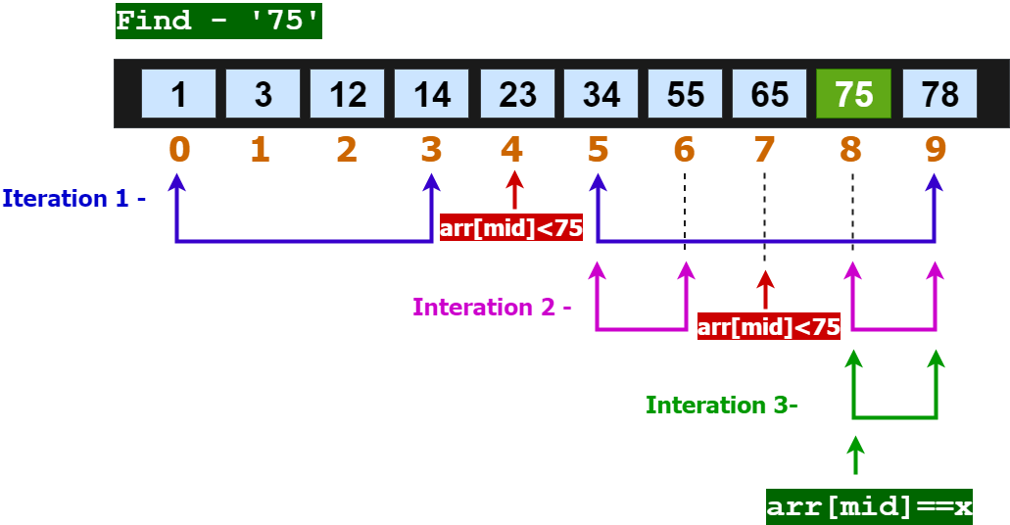

**Task 4:**

Implement the above array, sort it and find the value corresponding to to your last two digits of the roll number (if it’s not in the array add a value somewhere in between the array) and find it via binary search.

**Interpolation Search**

Interpolation search is an improvement over binary search. Binary Search always checks the value at middle index. But, interpolation search may check at different locations based on the value of element being searched. For interpolation search to work efficiently the array elements/data should be sorted and uniformly distributed.

Search key =33

***Position = startindex +***

**

**Algorithm**

1. **start = 0 & end = n-1**
2. **calculate position to start searching at using formula:**

***Position = startindex + $\frac{ (element-Arr\left[startindex\right])* \left(end value index -start value index\right) }{Arr\left[endindex\right] - Arr[startindex]}$***

1. **If A [pos] == Element, element found at index pos.**
2. **Otherwise if element > A[pos] we make start = pos + 1**
3. **Else if element < A[pos] we make end = pos -1**
4. **Do steps 2,3, 4, 5, While : start <= end && element >= A[start] && element =< A[end]**
   * **Start <= end - that is until we have elements in the sub-array.**
   * **Element >= A[start] - element we are looking for is greater than or equal to the starting element of sub-array we are looking in.**
   * **Element =< A[end] - element we are looking for is less than or equal to the last element of sub-array we are looking in.**

**Tasks 5:**

Write code for interpolation and show the iterations for uniformly distributed array.

**Note: An array is considered as uniformly distributed when the difference between the elements is equal or almost same. Example 1: 1,2,3,4,5,6 (Difference is 1)**